**ASSIGNMENT-VIEWS AND INDEXES**

**PRATIKSHA TAMBE(243072)**

create table vehicle(

vid int primary key,

vname varchar(20),

price int,

description varchar(20)

);

insert into vehicle values(1,'Activa',80000,'fdsdfgfbv');

insert into vehicle values(2,'Santro',800000,'bvxcvbcx');

insert into vehicle values(3,'Motor bike',100000,'bzbxv');

create table customer(

custid int primary key,

cname varchar(20),

address varchar(20)

);

insert into customer values(1,'Nilima','pimpari');

insert into customer values(2,'Ganesh','Pune');

insert into customer values(3,'Pankaj','Mumbai');

create table salesmans(

sid int primary key,

sname varchar(20),

address varchar(20)

);

insert into salesmans values(10,'Rajesh','Mumbai');

insert into salesmans values(11,'Seema','Pune');

insert into salesmans values(13,'Rakhi','Pune');

create table cust_vehicle(

custid int,

vid int,

sid int,

buy_price int ,

constraint fk1_sid foreign key(sid) references salesmans(sid),

primary key(custid, vid)

);

insert into cust_vehicle values(1,1,10,75000);

insert into cust_vehicle values(1,2,10,790000);

insert into cust_vehicle values(2,3,11,80000);

insert into cust_vehicle values(3,3,11,75000);

insert into cust_vehicle values(3,2,10,800000);

1. create all given tables

2. create index on vehicle table based on price

**create index vidx**

**on vehicle(price);**

3. find all customer name,vehicle name, salesman name, discount earn by all customer

**select c.cname, v.vname, s.sname, floor(((v.price-cu.Buy_price)/price)*100) "Discount %"**

**from customer c, vehicle v, salesmans s, cust_vehicle cu**

**where cu.custid=c.custid and**

**cu.vid=v.vid and**

**cu.sid=s.sid;**

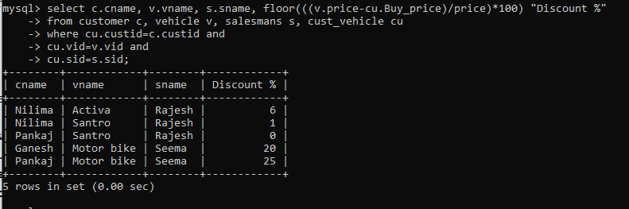

4. find all customer name,vehicle name,salesman name for all salesman who stays in pune

**select c.cname, v.vname, s.sname, cu.sid, s.address**

**from customer c, vehicle v, salesmans s, cust_vehicle cu**

**where s.address="pune"**

**and cu.custid=c.custid**

**and cu.sid=s.sid**

**and cu.vid=v.vid;**

**OR**

**select cname, vname, sname from cust_vehicle as cv**

**left join customer as c on cv.custid=c.custid**

**left join vehicle as v on cv.vid=v.vid**

**left join salesmans as s on cv.sid=s.sid**

**where s.address='Pune';**

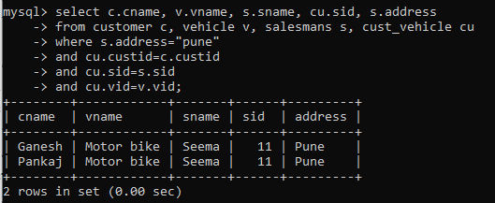

5. find how many customers bought motor bike

**select c.custid, c.vid, cu.cname "Customer Name"**

**from cust_vehicle c, customer cu**

**where vid=(select v.vid from vehicle v where vname="motor bike")**

**and c.custid=cu.custid;**

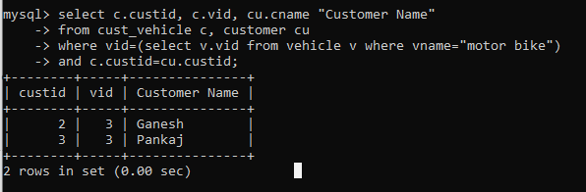

6. create a view find_discount which displays output

-------to create view

create view find_discount

as

select cname,vname,price,buying_price,price-buying_price “discount”

from customer c inner join cust_vehicle cv on c.custid=cv.cid inner join vehicle v on

v.vid=cv.vid

--------to display discount

select * from find_discount;

7. find all customer name, vehicle name, salesman name, discount earn by all customer

8. create view my_hr to display empno,ename,job,comm for all employees who earn commission

**create view my_hr as**

**select empno, ename, job, comm**

**from emp**

**where comm is not null and comm !=0;**

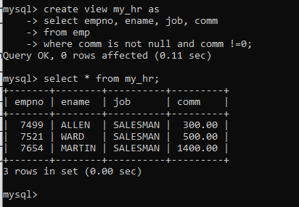

9. create view mgr30 to display all employees from department 30

**create view mgr30 as**

**select * from emp**

**where deptno=30;**

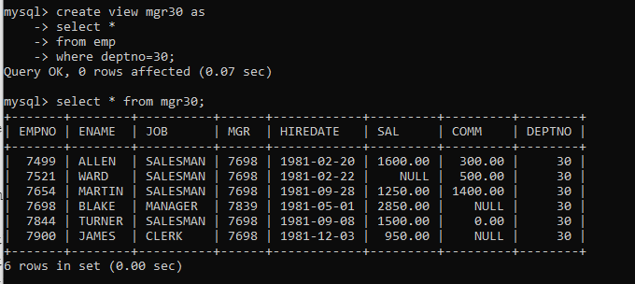

10. insert 3 employees in view mgr30 check whether insertion is possible

**The insertion is possible, the actual values are inserted in the emp table**

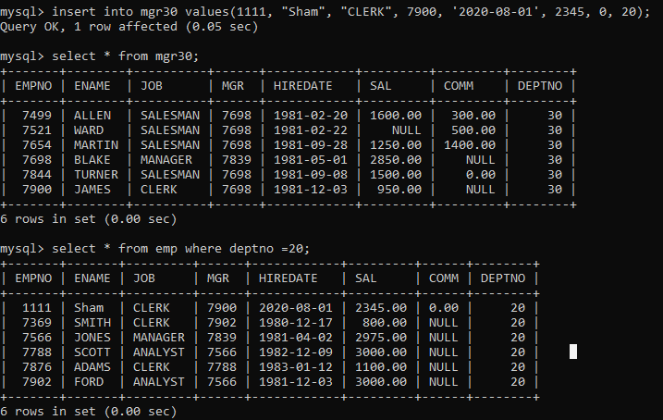

11. insert 3 records in dept and display all records from dept

**insert into dept values(50,"CLERK","DALLAS");**

**insert into dept values(70,"CLERK","DALLAS");**

**insert into dept values(60,"CLERK","DALLAS");**

12. use rollback command check what happens

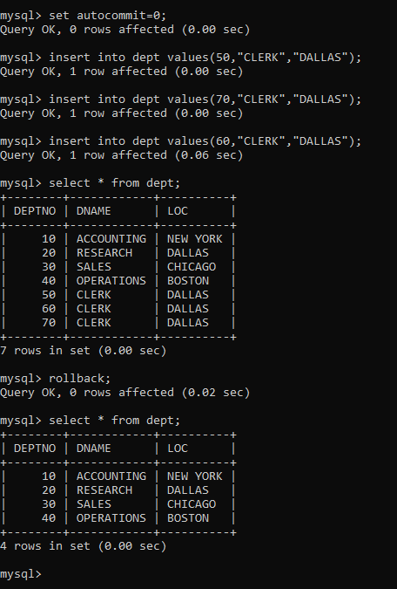

13. do the following

insert row in emp with empno 100

insert row in emp with empno 101

insert row in emp with empno 102

**insert into emp values(100,"ABC","CLERK",1111,"2020-01-02",1000,0,10);**

**insert into emp values(101,"ABC","CLERK",1111,"2020-01-02",1000,0,20);**

**insert into emp values(102,"ABC","CLERK",1111,"2020-01-02",1000,0,30);**

add savepoint A

**savepoint A;**

insert row in emp with empno 103

insert row in emp with empno 104

insert row in emp with empno 105

**insert into emp values(103,"ABC","CLERK",1111,"2020-01-02",1000,0,10);**

**insert into emp values(104,"ABC","CLERK",1111,"2020-01-02",1000,0,20);**

**insert into emp values(105,"ABC","CLERK",1111,"2020-01-02",1000,0,30);**

add savepoint B

**savepoint B;**

delete emp with empno 100

**delete from emp where empno=100;**

delete emp with emp no 104

**delete from emp where empno=104;**

rollback upto svaepoint B

**rollback to B;**

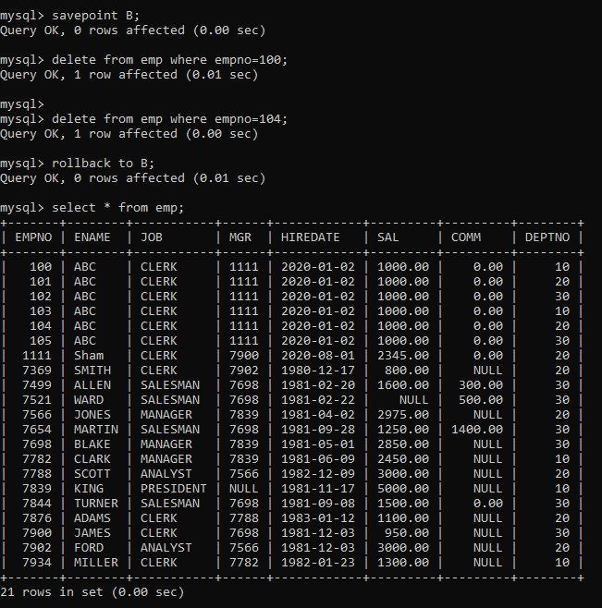

check what all records will appear in employee table rollback upto A;

**rollback to A;**

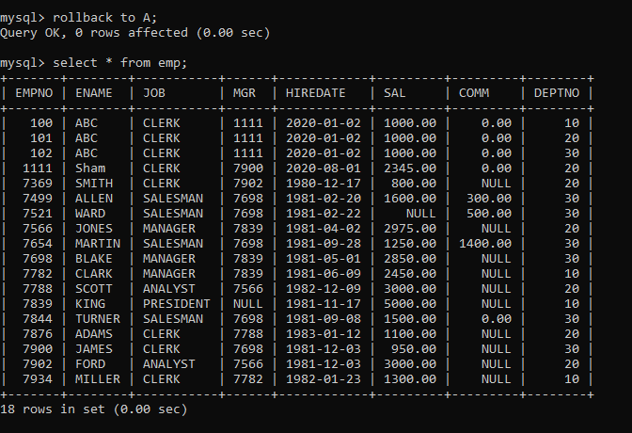

check what all records will appear in employee table commit all changes

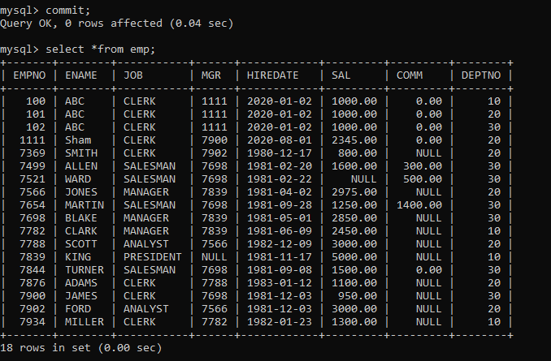

check what all records will appear in employee table

check whether you can roll back the contents.**(No)**

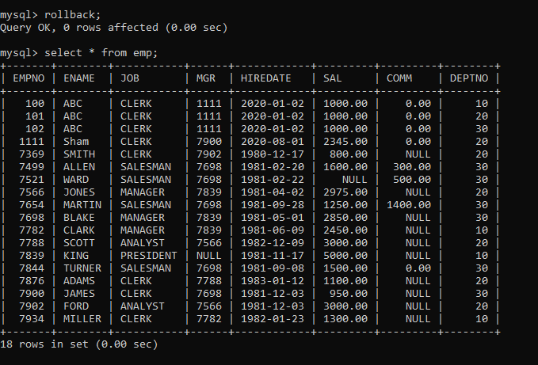

14. create a procedure getMin(deptno,minsal) to find minimum salary of given table.